H.T No
Regulations:
A18

Sreenidhi Institute of Science and Technology
(An Autonomous Institution)
Code No: 7EC67 Date: 14-June-2024 (FN)

B.Tech IV-Year I-Semester End External Examination, June - 2024 (Supplementary)
OPERATING SYSTEMS CONCEPTS - (OE-III) (ECE)

Time: 3 Hours Max.Marks:70

Note: a) No additional answer sheets will be provided.
b) All sub-parts of a question must be answered at one place only, otherwise it will not be valued.
c) Missing data can be assumed suitably.

Bloom's Cognitive Levels of Learning (BCLL)

Remember | L1 | Apply | L3 | Evaluate | L5
Understand | L2 | Analyze | L4 | Create | L6

Part - A Max.Marks:20
Answer all QUESTIONS

 |  | BCLL | CO(s) | Marks
1 | Define operating system. | L1 | CO1 | [2M]
2 | Write the various states of a process. | L1 | CO2 | [2M]
3 | What are the requirements that a solution to the Critical Section Problem must satisfy? | L1 | CO3 | [2M]
4 | Define deadlock. | L1 | CO4 | [2M]
5 | What do you mean by compaction? | L1 | CO5 | [2M]
6 | List any four common file types and their extensions. | L1 | CO6 | [2M]
7 | List any four system calls. | L1 | CO2 | [2M]
8 | Define Safe state and unsafe state. | L1 | CO3 | [2M]
9 | Define Logical address and Physical address. | L1 | CO5 | [2M]
10 | List the different types of Multiprocessing. | L1 | CO6 | [2M]
Part – B Max.Marks:50
ANSWER ANY FIVE QUESTIONS. EACH QUESTION CARRIES 10 MARKS.

 |  |  | BCLL | CO(s) | Marks
11. | a) | What are the functionalities of Operating Systems? Explain in detail. | L2 | CO1 | [5M]
 | b) | What are the different types of operating systems? Explain them in detail. | L2 | CO1 | [5M]
12. |  | - Consider the following four processes, with the length of the CPU burst time given in milliseconds.  - 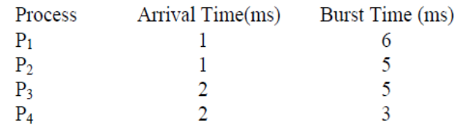  Compute Average Waiting Time and Turnaround time for given Process using FCFS and SJF Algorithms Draw the Gantt Chart as well. | L3 | CO2 | [10M]
13. | a) | What is critical section problem? Write and explain Peterson’s solution for it. | L3 | CO3 | [5M]
 | b) | Explain about Dinning philosopher problem. | L2 | CO3 | [5M]
14. |  | What is Resource-Allocation Graph? Explain Resource - Allocation Graph algorithm to avoid Deadlock with suitable example. | L3 | CO4 | [10M]
15. | a) | Differentiate between Internal fragmentation and external fragmentation. | L2 | CO5 | [5M]
 | b) | Write Short notes on Virtual memory. | L2 | CO5 | [5M]
16. |  | Explain Various File Allocation methods in detail. | L2 | CO6 | [10M]
17. | a) | Explain about any two generations of operating systems. | L2 | CO1 | [4M]
 | b) | Write short notes on Process Control Block(PCB). | L2 | CO2 | [3M]
 | c) | Explain about Monitors. | L2 | CO3 | [3M]
18. | a) | Explain four necessary conditions to be hold simultaneously to enter the system into Deadlock. | L1 | CO4 | [4M]
 | b) | Discuss about Demand paging. | L2 | CO5 | [3M]
 | c) | Write short notes on Free space Management. | L2 | CO6 | [3M]

-- 00 -- 00 –

